WordPress Intern Guide (Managing Posts)

1. Purpose of This Guide
As an intern, you may be required to help manage website content using WordPress. This guide focuses on using the Posts section to create new posts, view existing posts, and edit previously published content.

2. WordPress Home Page (Posts Dashboard)
After logging into WordPress, you will usually land on the Dashboard.
To manage posts:
1. Look at the left-hand sidebar.
2. Click on Posts.
This will bring you to the Posts home page, where all posts are listed.
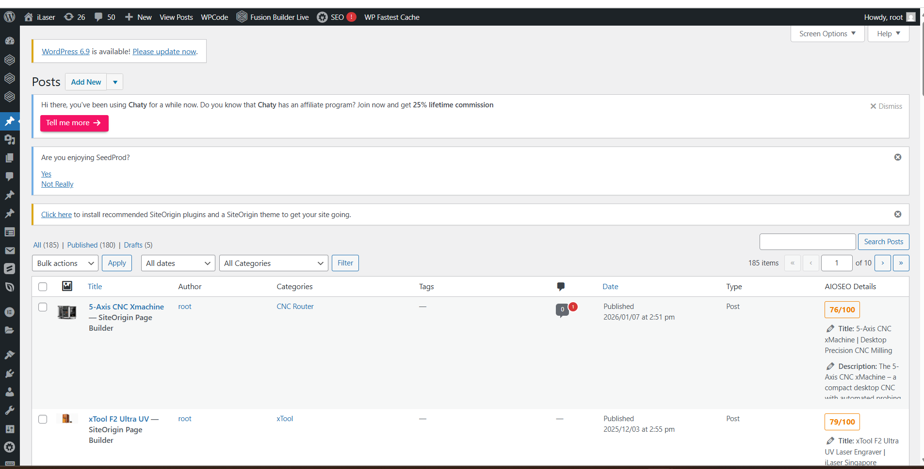

3. Understanding the Posts Page
On the Posts page, you can see:
- All posts (published and drafts)
- Post titles
- Author
- Categories
- Date published
- Post status (Published or Draft)
This page is mainly used to review, edit, and manage website content.

4. Adding a New Post
Steps to create a new post:
1. Click the Add New button at the top of the page.
2. A new post editor will open.
3. Enter the post title and content.
4. Assign the correct category if required.
5. Save your work as Draft unless instructed to publish.

5. Editing an Existing Post
To edit an existing post:
1. Locate the post in the Posts list.
2. Hover over the post title.
3. Click Edit.
You can then update text, images, and formatting.
After editing, click Update to save changes or Save Draft if not ready.

6. Viewing Old Posts
The Posts page allows you to:
- Scroll through older posts
- Use filters such as date and category
- Search for specific posts using keywords
This is useful for referencing older content or copying existing formats.

7. Important Notes for Interns
✅ Use the Posts page to manage content
✅ Edit existing posts instead of creating duplicates
✅ Save drafts before submitting for review
❌ Do not delete posts unless instructed
❌ Do not publish without supervisor approval

8. Quick Reference
- Posts → Add New: Create a new post
- Posts → Edit: Modify existing post
- Draft: Work in progress
- Published: Live on website

9. Creating a Product Post (Title, Category & Description)

9.1 Post Title
When creating a new post, the first field you will see is the Post Title.
This title should clearly state the name of the product. The title is important because it will be displayed on the website and may also appear in search engine results.
Guidelines for interns:
- Use the official product name
- Keep the title clear and concise
- Avoid unnecessary symbols or extra wording

9.2 Selecting the Product Category
On the right-hand side of the editor, you will find the Categories panel.
Here, you must select the category that best matches the product. Categories help organise products on the website and make them easier for users to find.
Guidelines for interns:
- Select the most relevant category
- Do not select multiple categories unless instructed
- If unsure, check similar existing posts

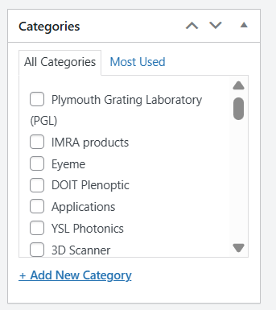

9.3 Product Description for Google Search (Meta Description)
The Meta Description is the short description that appears below the page title in Google search results.
This section is used to briefly describe the product and encourage users to click on the page.
Guidelines for interns:
- Keep the description short and clear (recommended under 160 characters)
- Describe what the product does and its key benefit
- Avoid copying long paragraphs from the main content
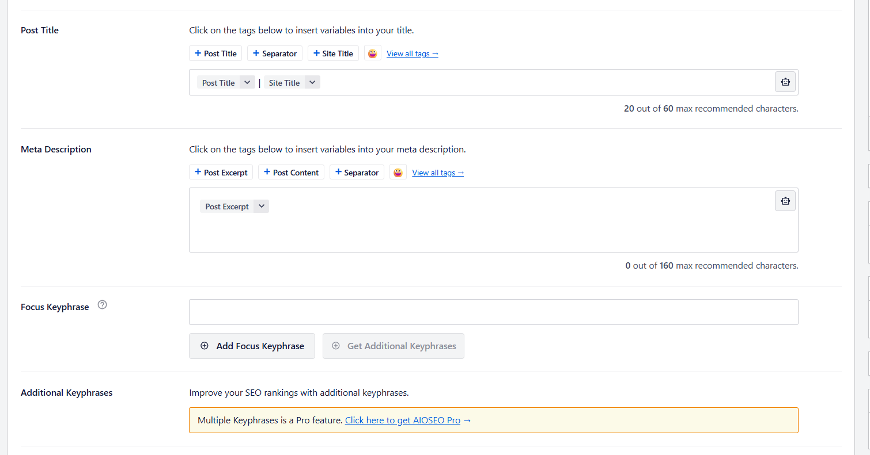

10. Building Pages Using Page Builder (SiteOrigin)

10.1 Selecting Page Builder
When creating or editing a post or page, select Page Builder to start building the website layout.
Page Builder allows you to structure the page using rows and widgets instead of typing everything as plain text.
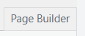

10.2 Adding Rows and Widgets
Once inside Page Builder, you can start designing the page.
Use the top buttons to:
- Add Row – create the page structure (columns)
- Add Widget – insert content into each row
Widgets are used to display text, images, buttons, and other content.
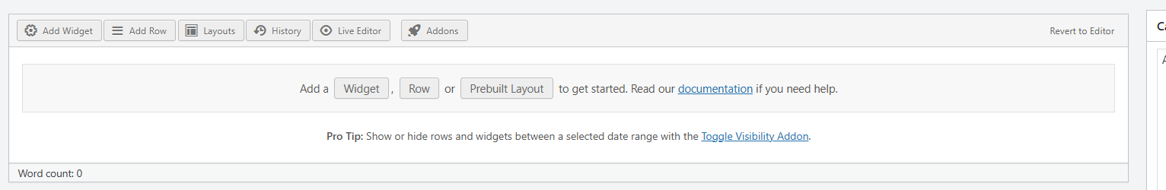

10.3 Using SiteOrigin Widgets Only
When building the website, interns must only use SiteOrigin widgets.
Common SiteOrigin widgets include:
- SiteOrigin Editor (for text and descriptions)
- SiteOrigin Image (for product images)
- SiteOrigin Button (for links and actions)
Do not use other widget types unless instructed by your supervisor.
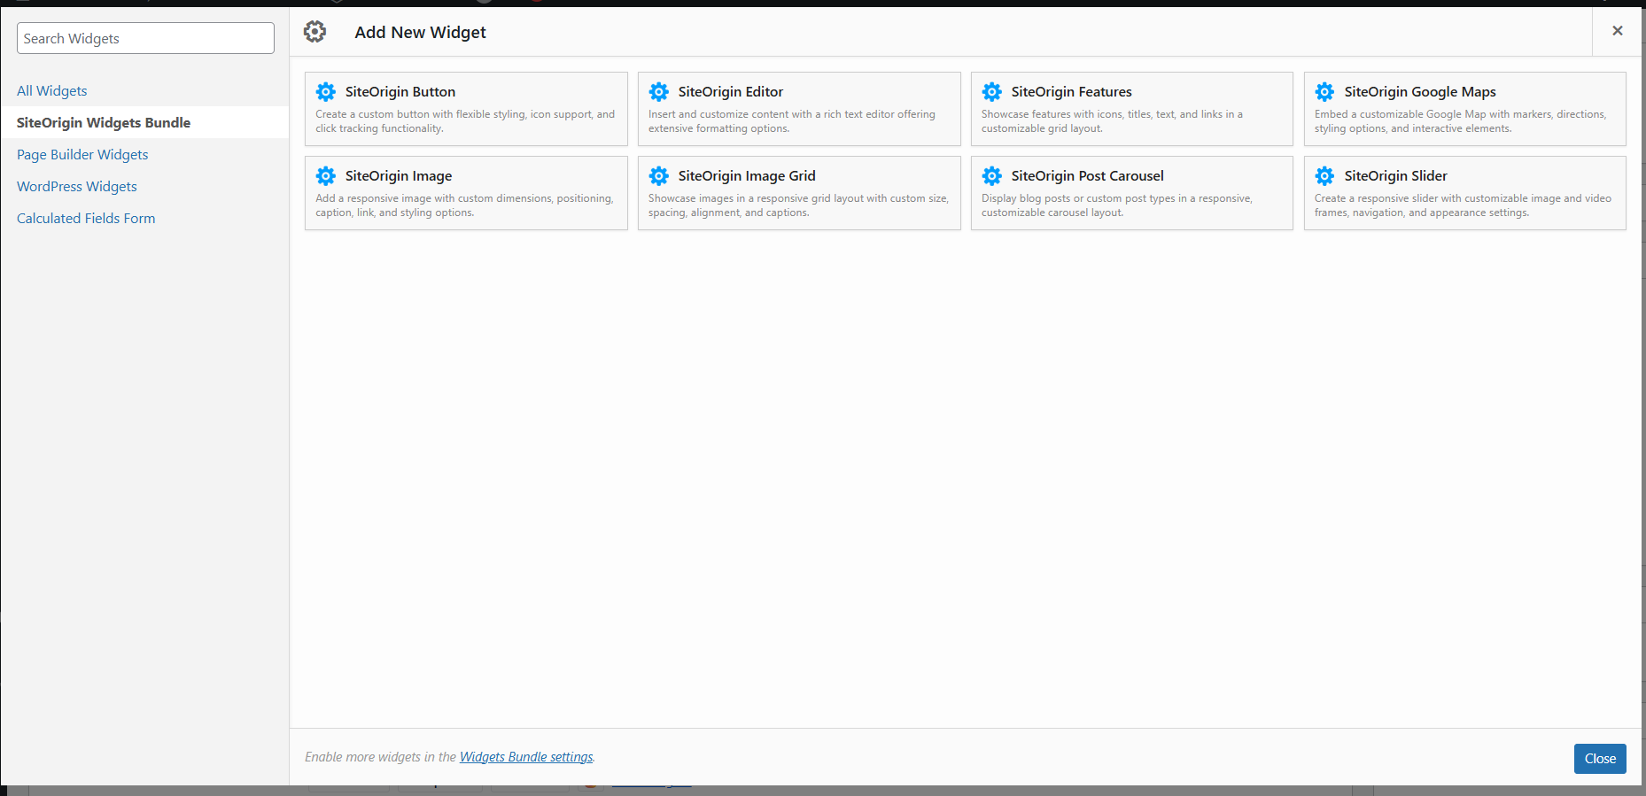

10.4 Example of a Fully Built Page
A completed page built using Page Builder should consist of well-structured rows and properly arranged widgets. Text, images, and features should be aligned neatly and follow the existing website style.
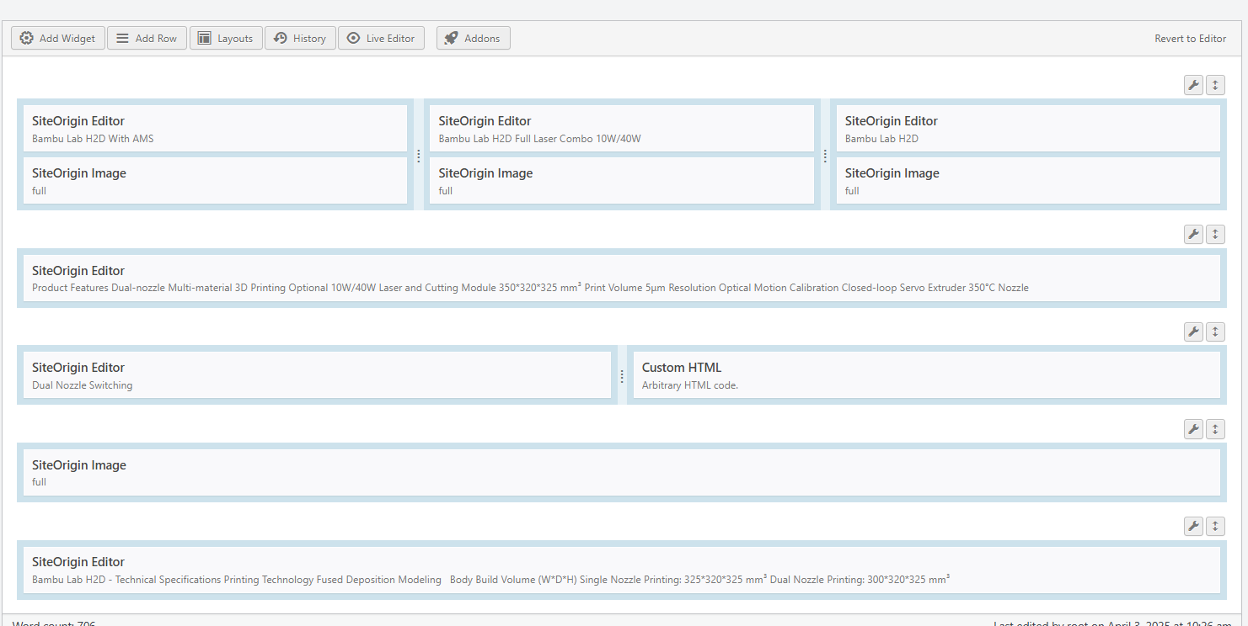

10.5 Important Notes for Interns
✅ Always use Page Builder when building or editing pages
✅ Use SiteOrigin widgets only
✅ Keep layout clean and consistent
❌ Do not mix Page Builder with the normal editor
❌ Do not change layouts drastically without approval

11. Editing Product Content Using HTML (SiteOrigin Editor)

11.1 Content Editing Page
This page appears when you are editing content inside a SiteOrigin Editor widget. It allows you to add and modify product descriptions, features, and specifications.
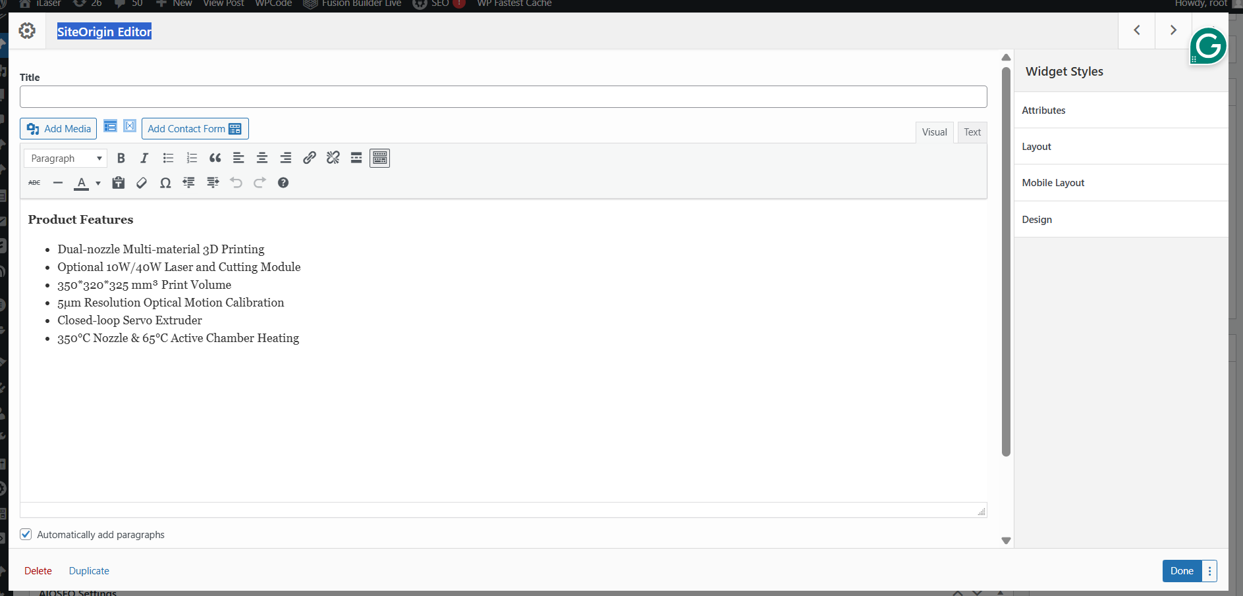

11.2 Copying HTML from an Existing Post
To keep formatting consistent across product pages, interns should reuse HTML from existing posts.
Steps:
1. Open an existing product post.
2. Switch the editor from Visual to Text.
3. Select the HTML code and copy it.
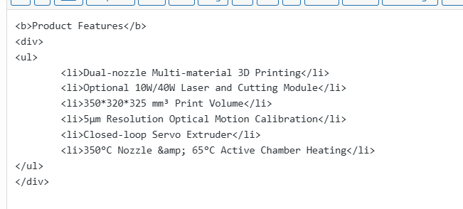

11.3 Using ChatGPT to Modify HTML Content
After copying the HTML code:
1. Paste the HTML into ChatGPT.
2. Ask ChatGPT to keep the same HTML structure and formatting.
3. Request only the content to be changed to match the new product.
4. Review the generated HTML carefully.

11.4 Pasting the Updated HTML Back into WordPress
Once the HTML has been updated:
1. Copy the new HTML code from ChatGPT.
2. Paste it into the Text tab of the SiteOrigin Editor.
3. Switch back to Visual mode to check formatting.
4. Save or update the page.

11.5 Important Notes for Interns
✅ Reuse HTML to maintain consistent formatting
✅ Always preview content after pasting HTML
❌ Do not change HTML structure unless instructed
❌ Do not paste unreviewed code directly into published pages

12. Adding Product into Categories

12.1 Adding Categories
1. Go to “posts”
2. Go to “Categories”
3. Go to “Add New Category”
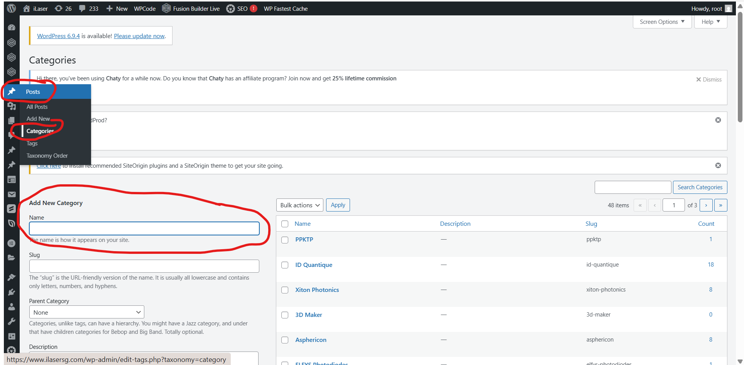

12.2 Check If The Post Is Under The Category Already
1. Go to “post”
2. Go to whichever post you are adding
3. Click on the category that you have just added

12.3 Adding Category To The Dropdown Menu
1. Go to “Appearance”
2. Go to “Menus”
3. Click on the category that you have just added
4. Click on “add to menu”
5. Scroll down to the bottom and drag the category to the desired spot
6. Click “Save Menu”
